CHAPTER 5 - ISA LEVEL

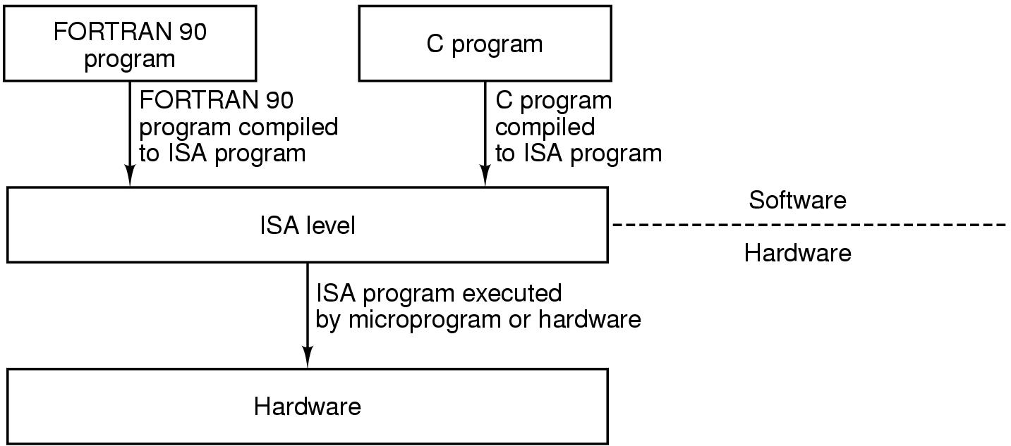

Programs in various high levels are translated to a common intermediate form: the ISA level.

ISA level is the interface between the compilers and the hardware.

When designing a new machine, the architects will talk both to the compiler writers and hardware engineers to find out what features each of them want in the ISA level.

Architects must keep the ISA the same between models i.e. durable. A good ISA is resistant to hardware changes.

What makes a good ISA?

- A good ISA should define a set of instructions that can be implemented efficiently in current and future technologies, resulting in cost-effective designs over several generations.
- A good ISA should make both hardware designers (easy to implement efficiently) and the software engineers happy (easy to generate code for.)

5.1 OVERVIEW OF THE ISA LEVEL

ISA level is defined by how the machine appears to a machine language programmer. ISA level code is what a compiler outputs. To produce ISA level code, the compiler writer has to know about what registers there are, what data types and instructions are available.

For some architecture, ISA level is specified by a formal defining document to make it possible for different implementers to build the machine and have them all run exactly the same software and get exactly the same results. For ex., SPARC.

Normative sections: Executing a reserved opcode shall cause a trap.
The effect of executing a reserved opcode is implementation defined.

REGISTERS

- special purpose registers: PC, SP
- general purpose registers:
- holds local variables and immediate results of calculations.
- Provides rapid access to heavily used data.

On some machines, general purpose registers are completely symmetric and interchangeable. The choice of register does not matter.

If there are system wide conventions on how the registers are to be used, compilers and assembly language programmers are advised to adhere to them.

In addition to ISA level registers visible to user programs, there are always a substantial number of special purpose registers available only in kernel mode. These registers control the various caches, memory, IO devices etc. They are used only by the OS. Example: PSW - control bits that reflect the status of the result of the most recent operation.

INSTRUCTIONS:

Data movement instructions, arithmetic instructions, Boolean instructions, branching instructions etc.

Overview of Core i7 ISA level: IA-32

Main goal: backward compatibility. Core i7 supports 8086 and 8088, it even contains remnants of the 8080, an 8 bit processor popular in the 1970s.
- 8086, 8088 and 80286 were 16 bit machines. Advantage of 80286 was the larger address space.
- 80386 was the first 32-bit machine in the Intel family. All the subsequent machines have the same 32 bit ISA: IA-32.
- Major architectural change after 80386 was MMX, SSE and SSE2 instructions to improve performance of multimedia applications.
- Another important extension: 64 bit x86 (Registers are 64 bits length, but the operations are still with 32 bits).

- Registers: 16 64 bit register, 8 32 bit registers

Overview of UltraSPARC ISA Level

- 64 bit architecture
- addressable memory is a linear array of 2⁶⁴ bytes.
- 2 groups of registers: 32 64 bit general purpose registers
32 floating point registers.

- Register windows: Ultra Sparc has more than 32 general purpose registers, although only 32 are visible to the program at any instant of time. Register windows is intended for the efficient support of procedure calls.

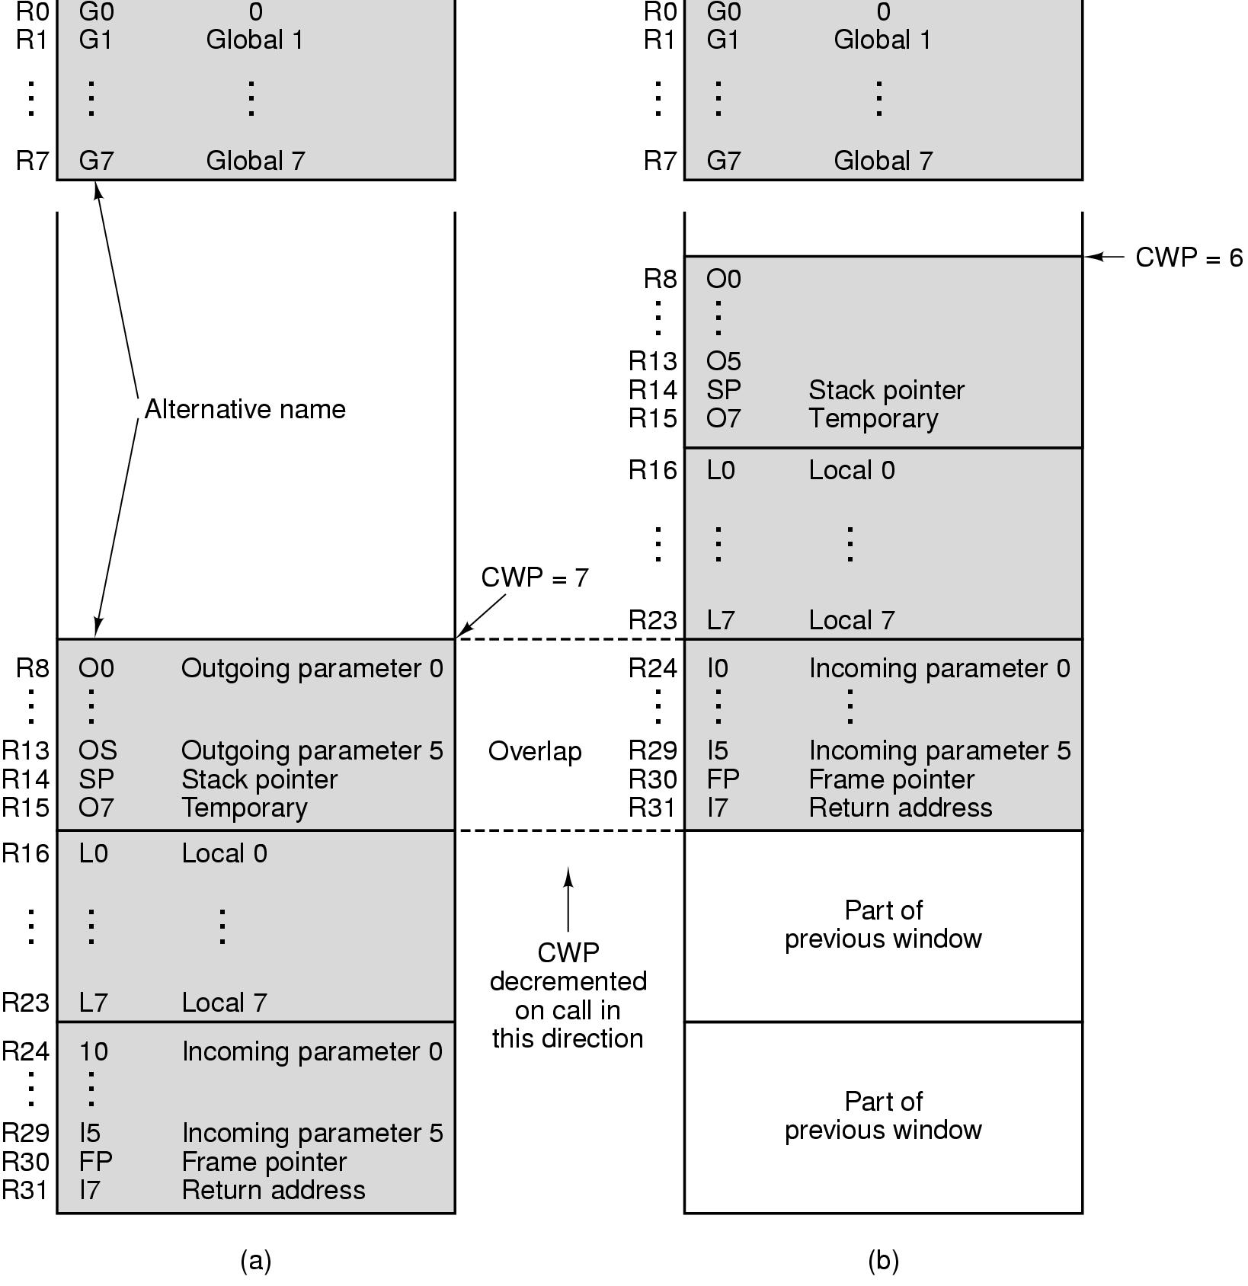

Overview of OMAP4430 ARM ISA Level

ARM version 7 ISA: 32 bit architecture

Registers:
- 2 groups of registers:
16 32 bit general purpose registers (R0-R15)
32 32 bit floating point registers (if VFP coprocessor is supported.)

When configured with VFP (Vector floating point processor), ARM ISA has 32 32 bit floating point registers. They can be accessed either directly as 32 single-precision floating point values or 16 64-bit double precision floating-point values. ARM floating point instructions come in single and double precision variants.

An important property of ARM architecture: It is a LOAD/STORE architecture.

Overview of ATmega168 AVR ISA Level

- One mode and no protection hardware since it never runs multiple programs owned by potentially hostile users.
- Simple memory model: 16 KB program memory, 1 KB data memory. These spaces are split to make it possible to implement the program space in flash and the data space in SRAM.
- Several implementations of memory are possible:

In the simplest case: There is a 4 KB flash for the program and a 512 byte SRAM for data. Both are on chip.

ATmega168 uses a two-tiered memory organization to provide better program security: Boot loader section and application section. Only code from boot loader can update flash memory. Boot loader loads the code only if it is digitally signed.

Registers:
- 32 8 bit general purpose registers, which are accessed by instructions via a 5-bit field specifying which register to use.
- General purpose registers and I/O devices are memory mapped.

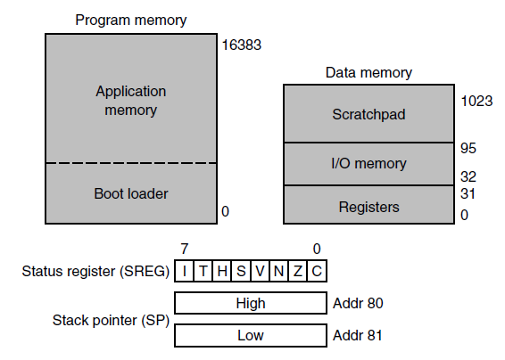

DATA TYPES

- Numeric: Integer, floating point, BCD
- Nonnumeric: Characters, strings, Booleans, pointers.

Core i7
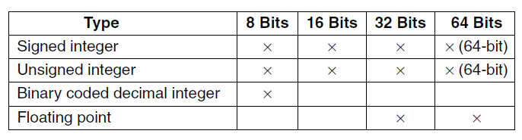

UltraSPARC III CPU
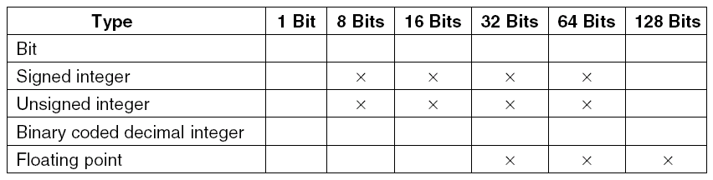

OMAP4430 ARM CPU
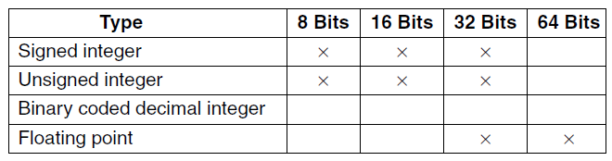

ATmega168 AVR CPU 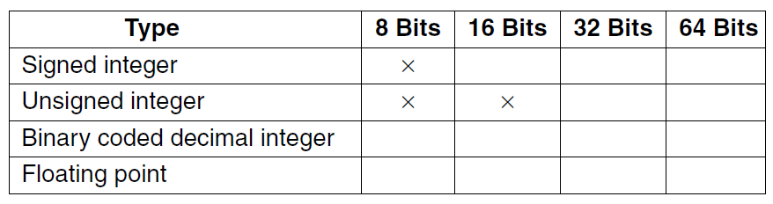

INSTRUCTION FORMATS

Four common instruction formats

- Zero address instructions
- One address instructions
- Two address instructions
- Three address instructions

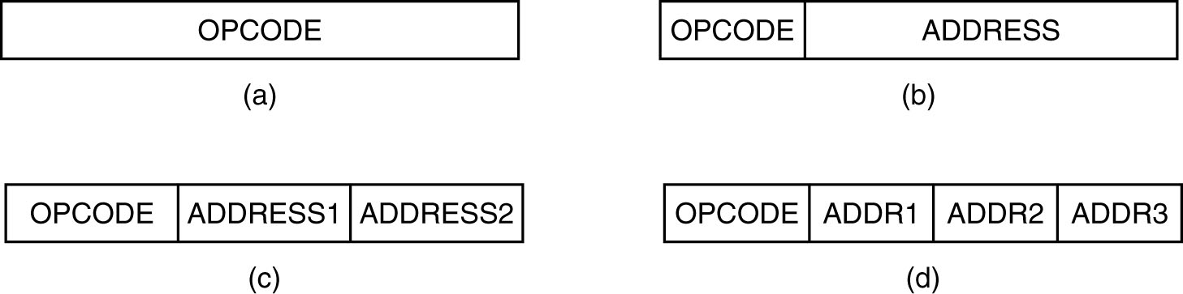

- Instructions may have the same length: simple, easy decoding but wastes space
- Instructions may have different lengths.

Instructions may be shorter than, the same length as, longer than the word length.

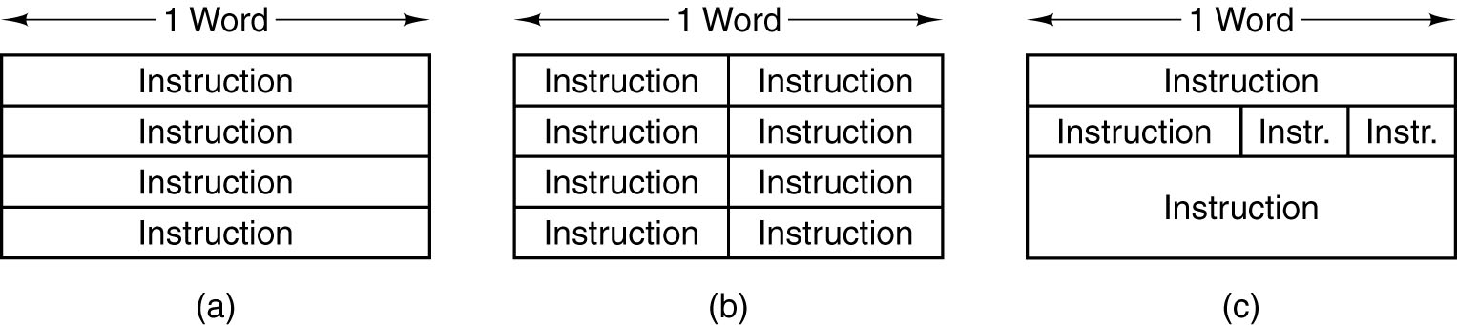

DESIGN CRITERIA FOR INSTRUCTION FORMATS

This decision must be made early in the design of a new computer. If the computer is commercially successful, the instruction set may survive for 20 years or more. The efficiency of a particular ISA is highly dependent on the technology with which the computer is to be implemented.

For example, if memory accesses are fast, a stack based design (like JVM) is a good one. If they are slow, having many registers (like the Ultra Sparc) is the way to go.

- Short instructions are better than the long ones.
- take up less memory
x harder to decode.

Achieving the minumum instruction size must be weighed against the time to decode and execute the instructions.

Memory bandwidth (the number of bits/sec that the memory can supply): the rate at which instructions may be limited by the instruction length and shorter instruction means faster processor.

Modern processors are able to execute multiple instructions every clock cycle.

- Sufficient room in the instruction format to express all operations desired must exist.

Core i7 Instruction Formats: highly complex and irregular, with upto 6 variable length fields, five of which are optional.

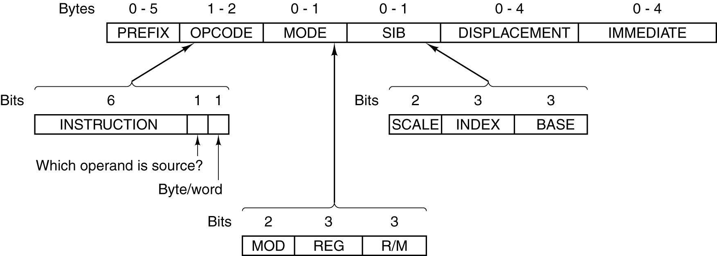

ULTRASPARC III CPU Instruction Formats: 32 bit simple instructions
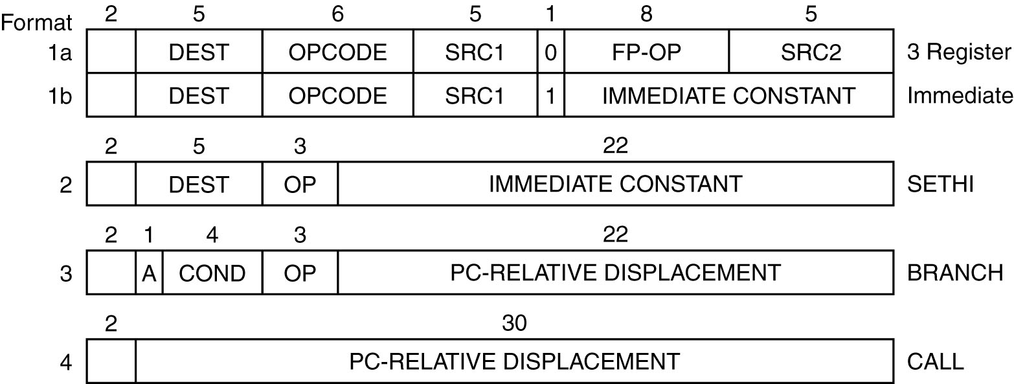

OMAP4430 ARM CPU Instruction Formats: 16 and 32 bit instructions aligned in memory. Instructions are generally simple.
Bits 26-27: determines instruction format.
Bits 28-31 is the condition field, which makes any instruction a predicated instruction. The condition is based on the processor status register (PSR).

Compared with SPARC formats, there are more instruction formats and decoding is more difficult. Therefore, SPARC is more RISC than OMAP4430.
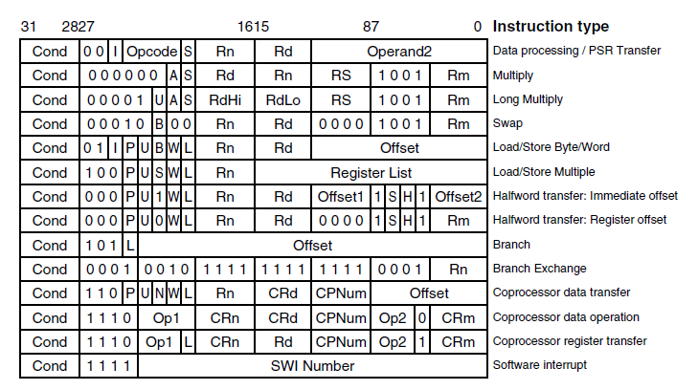

ATmega168 AVR Instruction Formats: Simple 2 or 4 byte instructions

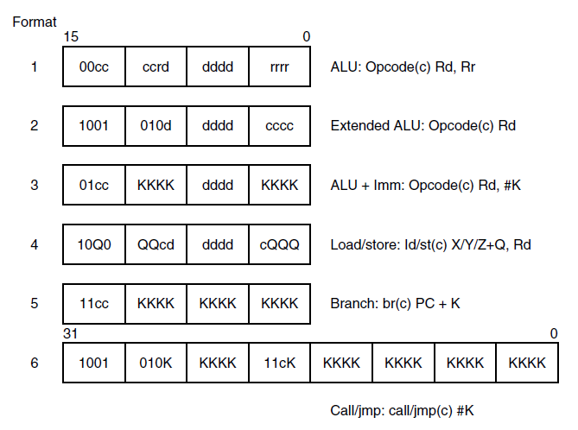

ADDRESSING MODES

Immediate addressing
Direct addressing
Register addressing
Register Indirect addressing
Indexed addressing
Based-Indexed Addressing
Stack addressing
Addressing modes for Branch Instructions: register indirect addressing, indexed mode, PC-relative addressing

From a software point of view, instructions and addressing should have a regular structure, with a minimum number of instruction formats for the compiler to produce good code.

Example 1: A simple design for the instruction formats of a three address machine
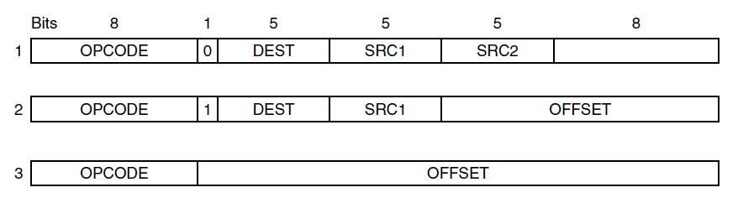

The Core i7 addressing modes: highly irregular and different depending whether a particular instruction is in 16, 32 or 64 bit mode: immediate, direct, register, register indirect, indexed, a special mode for addressing array elements. The problem is that not all modes apply to all instructions and not all registers can be used in all modes. This makes the compiler writer’s job much more difficult and leads to worse code. The MODE byte in the instruction controls the addressing modes:

MOD + REG +R/M One of the operands is specified by the
(2) (3) (3) combination of MOD and R/M fields. The
other operand is always a register.

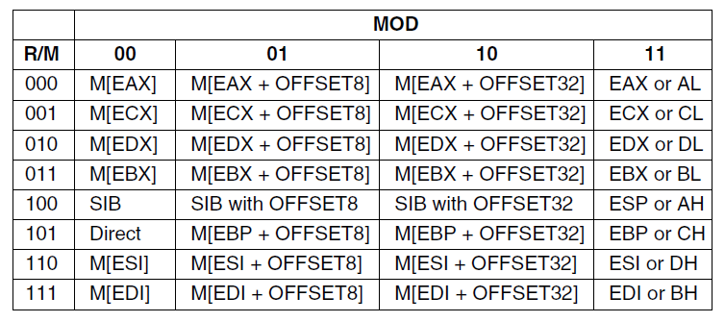

UltraSparc III addressing modes: all instructions use immediate and register addressing except for those that address memory. 3 kinds of instructions address memory: LOAD, STORE and one multiprocessor synchronization instruction.

The OMAP4430 ARM addressing modes: all instructions use immediate and register addressing except for those that address memory.
For register mode, the 5 bits tell which register to use..
For immediate mode, a 12-bit constant provides the data.
2 kinds of instructions address memory: load (LDR) and store (STR)

The ATmega168 AVR addressing modes: fairly regular addressing modes. There are 4 basic modes.
Register mode: the operand is in a register
Immediate mode: an 8 bit unsigned immediate can be encoded.
The remaining modes are usable by load and store instructions:
Direct mode: operand is in memory at the address contained in the instruction itself.
Register Indirect mode: A register contains a pointer to the operand.

Discussion of addressing modes:

Cleanest architectures have only a small number of addressing modes: Immediate, direct, register, indexed. Also, every register should be usable wherever a register is called for. More complicated addressing modes may reduce the number of instructions but at the expense of reduced possibility of parallelization.

INSTRUCTION TYPES

- Data Movement Instructions: LOAD, STORE, MOVE
- Dyadic operations: AND,OR...
- Monadic operations: Shift right, INC...
- Comparisons and conditional branches: Overflow, zero and carry detection
- Procedure Call Instructions
Where to put the return address: register, memory or stack?
- Loop control: for, do while, while do loops
- I/O: in ,out

COMPARISON OF INSTRUCTION SETS

Core i7: A classic two-address 32 bit CISC machine, with a long history, peculiar and irregular addressing modes, and many instructions that reference memory.

UltraSparc III: A modern 3 address 64 bit RISC, with a load-store architecture, hardly any addressing modes, and a compact instruction set. All instructions have the same size.

OMAP4430 ARM CPU: A modern 3 address 32 bit RISC, with a load-store architecture, hardly any addressing modes, and a compact and efficient instruction set.

ATmega168: A tiny embedded processor designed to fit on a single chip.

Design goals:

Design goal of Core i7 is backward compatibility. This makes compilers hard to write. The lack of registers forces compilers to spill variables into memory and then reload them.
UltraSPARC III represents a state-of-the-art ISA design.64 bit ISA with a 128 bit bus. Many registers and an instruction set with 3 register operations + LOAD and STORE instructions All instructions are of the same size
OMAP4430 ARM represents a state-of-the-art ISA design. It has a full 32 bit ISA. Many registers and an instruction set with 3 register operations + LOAD and STORE instructions All instructions are of the same size. Although the number of instruction formats has gotten a bit out of hand, it is still a straightforward and efficient implementation. Most new designs tend to look like the OMAP4430 ARM architecture, but with fewer instruction formats.
ATmega168 AVR: simple and fairly regular instruction set with relatively few instructions and addressing modes. It is distinguished by having 32 8 bit registers, rapid access to data, a way to access registers in the memory space. It can be implemented with a very small number of transistors, which keeps the cost per CPU very low.

